Software Requirement Specifications
Students Complaint Portal
A Web-Based Platform for Students Compalints


Submitted by
Shameen (S23BINFT1M01016)
Submitted to
MS Kainat

Department of Information Technology
Faculty of Computing
The Islamia University of Bahawalpur

Summary
The Students Complaint Portal is a web-based platform designed to streamline the process of reporting and resolving issues within an educational institution. It enables students to submit complaints related to academics, faculty behavior, or campus facilities either anonymously or with their personal details. Once submitted, each complaint is assigned a status that can be tracked by the student, ensuring visibility throughout the resolution process. The system also provides timely notifications and updates, keeping users informed until their issue is fully addressed.
This portal significantly improves communication between students and administration by offering a structured and accessible channel for feedback. The admin dashboard allows authorities to efficiently view, manage, and respond to complaints, helping prioritize issues and take appropriate actions بسرعة. By maintaining a well-organized record of all complaints, the system ensures accountability and helps in monitoring recurring problems.
Overall, the Students Complaint Portal enhances campus management by promoting transparency and faster resolution of issues. It creates a more responsive and student-friendly environment where concerns are acknowledged and addressed in a timely and efficient manner, ultimately contributing to better institutional performance and student satisfaction.

Table of Contents
1. Introduction 4
1.1. Purpose 4
1.2. Scope 4
1.3. Product Perspective 5
1.4. User Characteristics 6
1.5. Similar apps and systems/Literature Review 7
1.6. Proposed Technologies 11
2. Requirements 11
2.1. Function Requirements 12
2.1.1. Sign Up 12
2.2. Non-Functional Requirements 12
3. Use Cases and Flow of Processes 12
3.1. Use Case 1 13
4. References 14

- Introduction
  - Purpose
The purpose of the Students Complaint Portal is to design and develop a comprehensive web-based system that provides students with a reliable and structured platform to submit complaints related to academics, faculty behavior, and campus facilities. In many institutions, traditional complaint systems are manual, inefficient, and lack proper tracking, which often results in delays, mismanagement, or even complete neglect of student concerns. This system aims to eliminate such issues by introducing a digital solution that ensures every complaint is properly recorded, monitored, and resolved.
The portal not only allows students to submit complaints but also empowers them by providing transparency in the process. Students can choose to remain anonymous or disclose their identity, depending on their comfort level. This flexibility encourages more students to report genuine issues without fear. Additionally, the system strengthens accountability by ensuring that administrators respond to complaints within a structured workflow. Ultimately, the purpose of this system is to enhance communication, improve institutional responsiveness, and create a better academic environment.

  - Scope
The scope of the Students Complaint Portal covers the complete lifecycle of complaint management, starting from submission to final resolution. The system is designed to serve both students and administrative staff by providing dedicated functionalities for each user group. Students will be able to submit complaints through an easy-to-use interface, select relevant categories (such as academic issues, faculty-related concerns, or campus facilities), and optionally attach details or descriptions. Once submitted, each complaint is assigned a unique identification number, which can be used to track its progress.
The system also includes a tracking mechanism that allows students to monitor the status of their complaints in real-time. Status updates such as “Pending,” “In Progress,” or “Resolved” will be clearly displayed. Notifications will be sent to keep students informed about any changes or actions taken on their complaints. On the administrative side, the portal provides a dashboard where complaints can be viewed, sorted, filtered, and managed efficiently. Administrators can respond to complaints, update their status, and ensure timely resolution.
Furthermore, the system maintains a complete and organized database of all complaints, which can be used for reporting and analysis. This helps the institution identify recurring issues and take preventive measures. The portal is designed to be accessible via web browsers and compatible with multiple devices, ensuring ease of access and usability for all users.
  - Product Perspective
The Students Complaint Portal is a standalone web-based application that functions as an internal system within an educational institution. It follows a client-server architecture, where users interact with the system through a web interface, and all data processing and storage are handled by the backend server and database. The system acts as a bridge between students and the administration, enabling smooth communication and efficient issue resolution.
From a technical perspective, the portal integrates multiple components, including a user interface, application logic, and a database management system. It may also integrate with external services such as email or SMS gateways to provide notifications and updates to users. Unlike traditional systems that rely on paperwork or informal communication, this digital platform ensures that every complaint is documented and traceable.
The system is designed with scalability in mind, allowing it to handle a growing number of users and complaints over time. It can also be extended in the future to include additional features such as analytics dashboards, mobile applications, or integration with other institutional systems. Overall, the product provides a modern, efficient, and transparent solution to complaint management.

  - User Characteristics

Students (Primary Users):
Students are the main users of the system, and they come from diverse backgrounds with varying levels of technical expertise. Most students are expected to have basic knowledge of using web applications, such as navigating pages, filling out forms, and accessing information online. Their primary goal is to report issues quickly and easily, without facing complex procedures.
Students may prefer anonymity when submitting sensitive complaints, especially those related to faculty or personal concerns. Therefore, the system must be designed to ensure privacy and confidentiality. Students also expect timely updates and clear communication regarding the status of their complaints.

Administrators (Secondary Users):
Administrators are responsible for managing and resolving complaints. They require a moderate level of technical knowledge to operate the system effectively. Their tasks include reviewing complaints, categorizing them, responding to students, and updating their status. Administrators also play a key role in ensuring that complaints are handled fairly and within a reasonable time frame.

User Expectations:
Both students and administrators expect a system that is easy to use, fast, reliable, and accessible. The interface should be intuitive, and the system should provide clear instructions and feedback at every step.

  - Similar apps and systems/Literature Review

1.5.1 Similar websites and platforms
Several existing systems provide functionalities similar to the Students Complaint Portal. These systems serve as references for designing and implementing the proposed solution.
- University Complaint Systems: Many universities have internal portals where students can submit complaints or feedback regarding academic or administrative issues.
- Help Desk Systems (Ticketing Systems): Platforms used in IT support environments where users submit issues (tickets) and track their resolution status. These systems inspire features like unique IDs and status tracking.
- Online Feedback Platforms: Websites that collect user opinions, suggestions, and complaints, often used by organizations to improve services.
- Customer Support Systems: Systems used by companies to manage customer queries and complaints, emphasizing quick response and resolution.
These platforms highlight the importance of structured workflows, tracking mechanisms, and user communication.

1.5.2 systems/Literature Review
Studies and existing implementations of complaint management systems show that digital platforms significantly improve efficiency, transparency, and user satisfaction. Traditional manual systems often suffer from poor record-keeping, delays, and lack of accountability. Complaints may be lost or ignored, leading to frustration among users.
Modern systems address these issues by using centralized databases, automated workflows, and real-time tracking. Research indicates that providing users with visibility into the complaint process increases trust and engagement. Features such as notifications, dashboards, and reporting tools help administrators manage complaints more effectively.
The Students Complaint Portal is designed based on these principles. It ensures that every complaint is documented, tracked, and resolved systematically. The inclusion of anonymous submission further enhances its effectiveness by encouraging honest feedback. Overall, the system aligns with best practices in software design and user experience.

  - Proposed Technologies
- Frontend: HTML, CSS, JavaScript, Bootstrap
- Backend: PHP (Laravel Framework)
- Database: MySQL
Laravel is selected due to its robust architecture, built-in security features, and ease of development. Bootstrap is used to create a responsive and user-friendly interface, while MySQL ensures efficient data storage and retrieval.

- Requirements
Authors have to provide a brief of functions of the project. For example, if a Hospital Management System is going to develop and Patient and Doctor module is going to implement then patient admission, appointment system and billing can be described here. Authors will write these items in the form of paragraph without providing some title.

2.1 Functional Requirements
- FR001: User Registration
The system shall allow students to create an account by providing necessary details such as name, email, and password.
- FR002: User Login
The system shall authenticate users and allow secure login for both students and administrators.
- FR003: Anonymous Complaint Submission
The system shall allow students to submit complaints without revealing their identity.
- FR004: Named Complaint Submission
The system shall allow students to submit complaints with personal details.
- FR005: Complaint Categorization
The system shall allow users to categorize complaints into predefined categories.
- FR006: Complaint ID Generation
The system shall generate a unique identifier for each complaint.
- FR007: Complaint Tracking
The system shall allow users to track complaint status using the generated ID.
- FR008: Notifications System
The system shall send notifications regarding complaint updates.
- FR009: Admin Dashboard Access
The system shall provide a dashboard for administrators to manage complaints.
- FR010: View Complaints
The system shall allow administrators to view all submitted complaints.
- FR011: Respond to Complaints
The system shall allow administrators to respond to complaints.
- FR012: Update Complaint Status
The system shall allow administrators to update the status of complaints.
- FR013: Search and Filter Complaints
The system shall allow filtering based on category, date, or status.
- FR014: Manage Complaints
The system shall allow administrators to delete or manage invalid complaints.
- FR015: Report Generation
The system shall generate reports for analysis and decision-making.

2.2 Non-Functional Requirements
- Security: The system must ensure data protection and confidentiality.
- Usability: The interface should be simple and easy to use.
- Performance: The system should respond quickly to user actions.
- Reliability: The system should be available with minimal downtime.
- Scalability: The system should support increasing users and data.
- Maintainability: The system should be easy to update and maintain.

- Use Cases and Flow of Processes
Use cases are the formal representation of process flow defined by functional requirements. Authors should provide a flow of events in this. There should be system level use case which is directly influenced to project functions with their user(s) (called actor(s)) which are described in requirements chapters

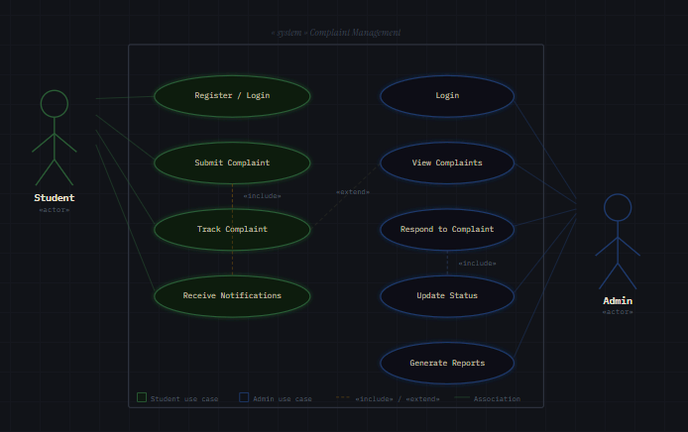
Figure 1: System Level Use Case Diagram

  - Use Case 1
ID | UC001
Name | Submit Complaint
Description | This use case describes the process flow of Complaint
Requirement(s) | FR001
Actor(s) | Students
Precondition | Actors must be student
Postcondition | Actors will view the comlaint status
Basic Flow | Basic Flow  · The student accesses the complaint portal  · The system displays the complaint submission form  · The student selects whether to remain anonymous or provide details  · The student enters complaint information and selects category  · The student submits the complaint  · The system validates the input data  · The system stores the complaint in the database  · A unique complaint ID is generated  · The system displays a confirmation message  Alternative Flow  · If the user provides invalid input, the system displays an error message  · If anonymous option is selected, personal data is not stored  Exceptions  - Invalid Inputs  - System unable to response

Activity Diagram

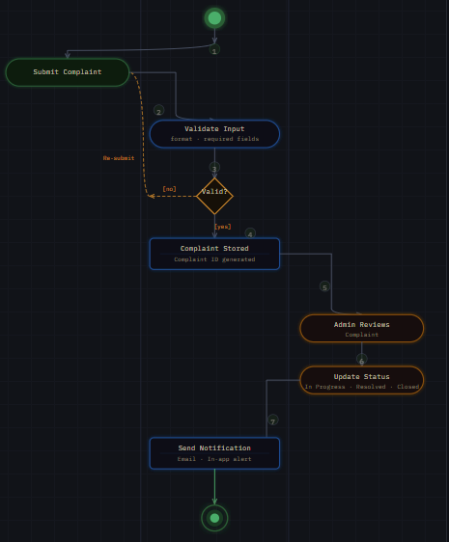

- References
Author should provide references in IEEE format

